**Daily Assessment**

**Muhammad Ammar Chaudhry**

**SU92-BSCSM-F23-269**

**BSCS-1G**

**----------------------------------------------------------------------------------------------------**

**Q#11:**

**#include<iostream>**

**#include <iomanip>**

**using namespace std;**

**int main()**

**{**

**double num=1.23e+09;**

**cout<<"Without fixed flag: "<<num<<endl;**

**cout<<fixed<<setprecision(5)<<"With fixed flag: "<<num<<endl;**

**}**

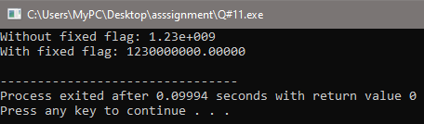

**Q#12:**

**#include<iostream>**

**#include<iomanip>**

**using namespace std;**

**int main()**

**{**

**double pi=3.14159, year=2006, value=1e-10;**

**cout<<"Default:"<<endl;**

**cout<<pi<<endl;**

**cout<<year<<endl;**

**cout<<value<<endl;**

**cout<<endl;**

**cout<<"Fixed:"<<endl;**

**cout<<fixed<<pi<<setprecision(5)<<endl;**

**cout<<fixed<<year<<setprecision(5)<<endl;**

**cout<<fixed<<value<<setprecision(5)<<endl;**

**cout<<endl;**

**cout<<"Scientific:"<<endl;**

**cout<<scientific<<pi<<endl;**

**cout<<scientific<<year<<endl;**

**cout<<scientific<<value<<endl;**

**return 0;**

**}**

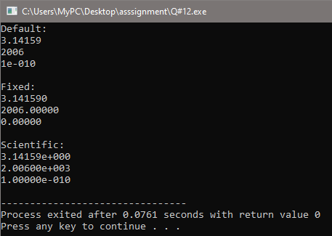

**Q#13:**

**#include<iostream>**

**#include<iomanip>**

**using namespace std;**

**int main()**

**{**

**double num1=30.0;**

**double num2=10000.0;**

**double pi=3.1416;**

**cout<<fixed<<setprecision(3)<<num1<<setw(10)<<setprecision(0)<<num2<<setw(10)<<setprecision(4)<<pi;**

**cout<<endl;**

**cout<<setprecision(0)<<num1<<setw(10)<<setprecision(0)<<num2<<setw(10)<<setprecision(4)<<pi;**

**cout<<endl;**

**return 0;**

**}**

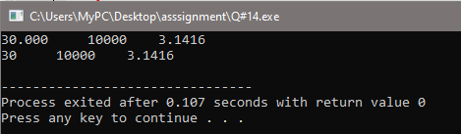

**Q#14:**

**#include<iostream>**

**#include<iomanip>**

**using namespace std;**

**int main()**

**{**

**double num1=192.9864;**

**double num2=168.0000;**

**double pi=3.141590;**

**cout<<fixed<<setprecision(2)<<num1<<endl;**

**cout<<fixed<<setprecision(2)<<num2<<endl;**

**cout<<fixed<<setprecision(2)<<pi<<endl;**

**cout<<endl;**

**cout<<fixed<<setprecision(4)<<num1<<endl;**

**cout<<fixed<<setprecision(4)<<num2<<endl;**

**cout<<fixed<<setprecision(4)<<pi<<endl;**

**cout<<endl;**

**cout<<fixed<<setprecision(6)<<num1<<endl;**

**cout<<fixed<<setprecision(6)<<num2<<endl;**

**cout<<fixed<<setprecision(6)<<pi<<endl;**

**cout<<endl;**

**return 0;**

**}**

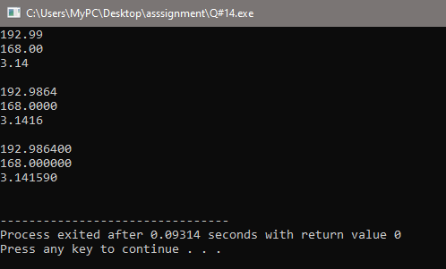

**Q#15:**

**#include <iostream>**

**#include <iomanip>**

**using namespace std;**

**int main(){**

**int z=-24;**

**cout.width(6);**

**cout<<internal<<z<<endl;**

**cout.width(6);**

**cout<<left<<z<<endl;**

**cout.width(6);**

**cout<<right<<z<<endl;**

**}**

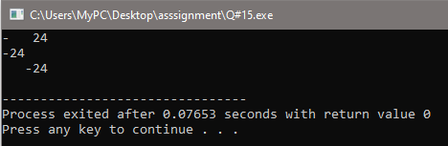

**Q#16:**

**#include<iostream>**

**#include<iomanip>**

**using namespace std;**

**int main()**

**{**

**double number = 1.23;**

**cout << left << setfill('*') << setw(10) << -number << endl;**

**cout << left << setfill('*') << setw(10) << hex << showbase << 42 << endl;**

**cout << left << setfill('*') << setw(10) << setprecision(2) << fixed << "USD " << number << endl;**

**cout << endl;**

**cout << internal << setfill('*') << setw(10) << -number << endl;**

**cout << internal << setfill('*') << setw(10) << hex << showbase << 42 << endl;**

**cout << internal << setfill('*') << setw(10) << setprecision(2) << fixed << "USD " << number << endl;**

**cout << endl;**

**cout << right << setfill('*') << setw(10) << -number << endl;**

**cout << right << setfill('*') << setw(10) << hex << showbase << 42 << endl;**

**cout << right << setfill('*') << setw(10) << setprecision(2) << fixed << "USD " << number << endl;**

**}**

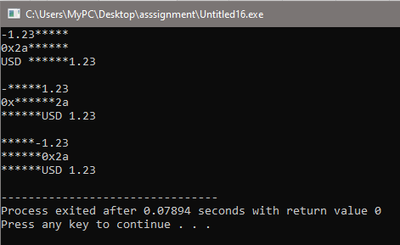

**Q#17:**

**#include<iostream>**

**#include<iomanip>**

**using namespace std;**

**int main()**

**{**

**int num=5;**

**cout<<num<<endl;**

**cout<<setw(10)<<right<<num<<endl;**

**cout<<num<<endl;**

**cout<<num<<endl;**

**cout<<setw(10)<<right<<num<<endl;**

**cout<<setw(10)<<right<<num<<endl;**

**}**

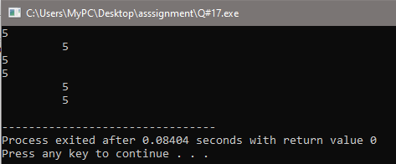

**Q#18:**

**#include<iostream>**

**#include<iomanip>**

**using namespace std;**

**int main()**

**{**

**int num=24;**

**cout<<"-"<<setw(4)<<right<<num<<endl;**

**cout<<-num<<endl;**

**cout<<setw(5)<<right<<-num<<endl;**

**}**

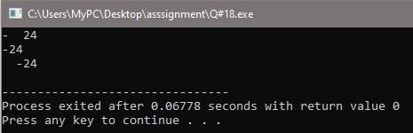

**Q#19:**

**#include <iostream>**

**using namespace std;**

**int main()**

**{**

**int x, y, temp;**

**cout<<"Enter the value for x: ";**

**cin>>x;**

**cout<<"Enter the value for y: ";**

**cin>>y;**

**cout<<"Original values:"<<endl;**

**cout<<"x: "<<x<<endl;**

**cout<<"y: "<<y<<endl;**

**temp = x;**

**x = y;**

**y = temp;**

**cout<<"After exchange:"<<endl;**

**cout<<"x: "<<x<<endl;**

**cout<<"y: "<<y<<endl;**

**}**

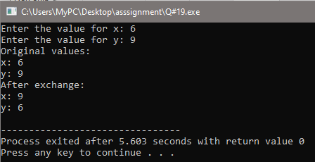

**Q#20:**

#include<iostream>

using namespace std;

int main()

{

int num1,num2;

int add,sub,mul,div,mod;

cout<<"Enter first number: ";

cin>>num1;

cout<<"Enter second number: ";

cin>>num2;

add=num1+num2;

sub=num1-num2;

mul=num1*num2;

div=num1/num2;

mod=num1%num2;

cout<<"Sum is: "<<add<<endl;

cout<<"Difference is: "<<sub<<endl;

cout<<"Product is: "<<mul<<endl;

cout<<"Quotient is: "<<div<<endl;

cout<<"Remainder is: "<<mod<<endl;

}

